**What is Cloud Computing?**

**Cloud Computing** is defined as storing and accessing of data and computing services over the internet. It doesn’t store any data on your personal computer. It is the on-demand availability of computer services like servers, data storage, networking, databases, etc. The main purpose of cloud computing is to give access to data centers to many users. Users can also access data from a remote server.

**Examples of Cloud Computing Services:** AWS, Azure, Google Cloud

[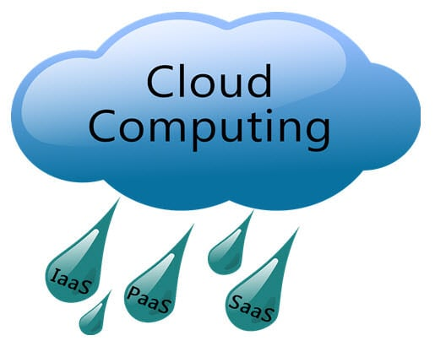](https://www.guru99.com/images/blog_image/cloud_computing_1.jpg)

Let’s learn Cloud Computing basics with an example –

Whenever you travel through a bus or train, you take a ticket for your destination and hold back to your seat till you reach your destination. Likewise other passengers also takes ticket and travel in the same bus with you and it hardly bothers you where they go. When your stop comes you get off the bus thanking the driver. Cloud computing is just like that bus, carrying data and information for different users and allows to use its service with minimal cost.

## Why the Name Cloud?

The term “Cloud” came from a network design that was used by network engineers to represent the location of various network devices and there inter-connection. The shape of this network design was like a cloud.

[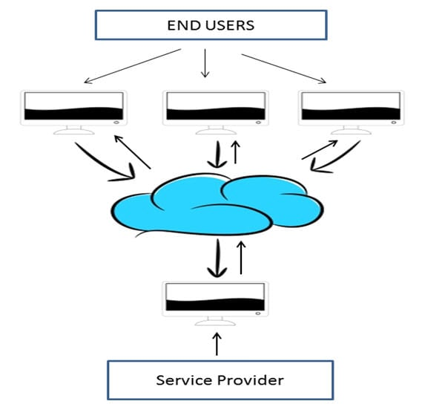](https://www.guru99.com/images/blog_image/cloud_computing_2.jpg)

## Why Cloud Computing?

With increase in computer and Mobile user’s, data storage has become a priority in all fields. Large and small scale businesses today thrive on their data & they spent a huge amount of money to maintain this data. It requires a strong IT support and a storage hub. Not all businesses can afford high cost of in-house IT infrastructure and back up support services. For them Cloud Computing is a cheaper solution. Perhaps its efficiency in storing data, computation and less maintenance cost has succeeded to attract even bigger businesses as well.

Cloud computing decreases the hardware and software demand from the user’s side. The only thing that user must be able to run is the cloud computing systems interface software, which can be as simple as Web browser, and the Cloud network takes care of the rest. We all have experienced cloud computing at some instant of time, some of the popular cloud services we have used or we are still using are mail services like gmail, hotmail or yahoo etc.

While accessing e-mail service our data is stored on cloud server and not on our computer. The technology and infrastructure behind the cloud is invisible. It is less important whether cloud services are based on HTTP, XML, Ruby, PHP or other specific technologies as far as it is user friendly and functional. An individual user can connect to cloud system from his/her own devices like desktop, laptop or mobile.

Cloud computing harnesses small business effectively having limited resources, it gives small businesses access to the technologies that previously were out of their reach. Cloud computing helps small businesses to convert their maintenance cost into profit. Let’s see how?

In an in-house IT server, you have to pay a lot of attention and ensure that there are no flaws into the system so that it runs smoothly. And in case of any technical glitch you are completely responsible; it will seek a lot of attention, time and money for repair. Whereas, in cloud computing, the service provider takes the complete responsibility of the complication and the technical faults.

## Types of Clouds

There are four different cloud models that you can subscribe according to business needs. Following are the different Types of Clouds:

[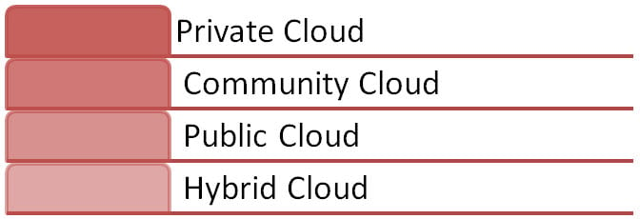](https://www.guru99.com/images/blog_image/cloud_computing_3.jpg)Types of Clouds

1. **Private Cloud:**Here**,**computing resources are deployed for one particular organization. This method is more used for intra-business interactions. Where the computing resources can be governed, owned and operated by the same organization.
2. **Community Cloud:**Here**,**computing resources are provided for a community and organizations.
3. **Public Cloud:**This type of cloud is used usually for B2C (Business to Consumer) type interactions. Here the computing resource is owned, governed and operated by government, an academic or business organization.
4. **Hybrid Cloud:**This type of cloud can be used for both type of interactions – B2B (Business to Business) or B2C ( Business to Consumer). This deployment method is called hybrid cloud as the computing resources are bound together by different clouds.

## Benefits of Cloud Computing

The potential for cost saving is the major reason of cloud services adoption by many organizations. Cloud computing gives the freedom to use services as per the requirement and pay only for what you use. Due to cloud computing it has become possible to run IT operations as a outsourced unit without much in-house resources.

Now in this Cloud Computing tutorial, we will learn the benefits of Cloud Computing.

1. Lower IT infrastructure and computer costs for users
2. Improved performance
3. Fewer Maintenance issues
4. Instant software updates
5. Improved compatibility between Operating systems
6. Backup and recovery
7. Performance and Scalability
8. Increased storage capacity
9. Increase data safety

## Examples of Cloud Computing

Here are some examples of Cloud computing applications:

**Health Care:**

Medical professionals can do diagnostics, host information, and analyze patients remotely with the help of cloud computing. Cloud computing allows doctors to share information quickly from anywhere. It also saves costs by allowing large data file transfers instantly. This certainly increases efficiency.

Ultimately, cloud technology helps the medical team ensure patients receive the best possible care without unnecessary delay. The condition of patients can also be updated in seconds with the help of remote conferencing.

**Education:**

Cloud computing is also useful in educational institutions for distance learning. It offers various services for universities, colleges, professors, and teachers to reach thousands of students all around the world. Companies like Google and Microsoft offer various services free of charge to faculties, teachers, professors, and students from various learning institutions. Various educational institutions across the world use these services to improve their efficiency and productivity.

**Government:**

The U.S. military and government were early adopters of cloud computing. Their Cloud incorporates social, mobile, and analytics technologies. Although, they must adhere to strict compliance and security measures (FIPS, FISMA, and FedRAMP). This protects against cyber threats both domestically and abroad.

**Big data Analytics:**

Cloud computing helps data scientists analyze various data patterns, insights for better predictions and decision making. There are many open-source big data development and analytics tools available like Cassandra, Hadoop, etc., for this purpose.

**Communication:**

Cloud computing provides network-based access to communication tools like emails and social media. WhatsApp also uses a cloud-based infrastructure to facilitate user communications. All the information is stored in the service provider’s hardware.

**Business Process:**

Nowadays, many business processes like emails, ERP, CRM, and document management have become cloud-based services. SaaS has become the most vital method for enterprises. Some examples of SaaS include Salesforce, HubSpot.

**Facebook, Dropbox, and Gmail:**

Cloud computing can be used for the storage of files. It helps you automatically synchronize the files from different devices like desktop, tablet, mobile, etc. Dropbox allows users to store and access files up to 2 GB for free. It also provides an easy backup feature.

Social Networking platforms like Facebook demand powerful hosting to manage and store data in real-time. Cloud-based communication provides click-to-call facilities from social networking sites and access to the instant messaging system.

**Citizen Services:**

The cloud technology can be used for handling citizen services too. It is widely used for storing, managing, updating citizen details, acknowledging forms, and even verifying the current status of applications can be performed with the help of cloud computing.

## Cloud Computing Services

The three major Cloud Computing Offerings are

* **Software as a Service (SaaS)**
* **Platform as a Service (PaaS)**
* **Infrastructure as a Service (IaaS)**

Different business use some or all of these components according to their requirement.

[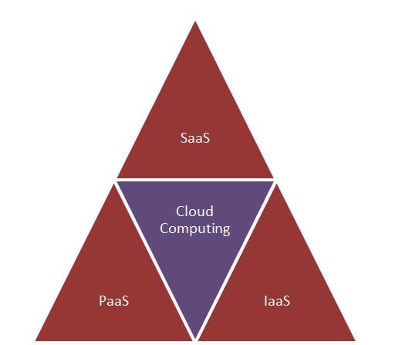](https://www.guru99.com/images/blog_image/cloud_computing_4.jpg)

### SaaS (Software as a Service)

SaaS or software as a service is a software distribution model in which applications are hosted by a vendor or service provider and made available to customers over a network (internet). SaaS is becoming an increasingly prevalent delivery model as underlying technologies that supports **Service Oriented Architecture (SOA) or Web Services**. Through internet this service is available to users anywhere in the world.

[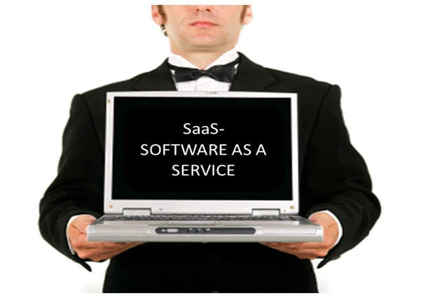](https://www.guru99.com/images/blog_image/cloud_computing_5.jpg)

Traditionaly, software application needed to be purchased upfront &then installed it onto your computer. SaaS users on the other hand, instead of purchasing the software subscribes to it, usually on monthly basisvia internet.

Anyone who needs an access to a particular piece of software can be subscribe as a user, whether it is one or two people or every thousands of employees in a corporation. SaaS is compatible with all internet enabled devices.

Many important tasks like accounting, sales, invoicing and planning all can be performed using SaaS.

### PaaS (Platform as a Service)

Platform as a service, is referred as PaaS, it provides a platform and environment to allow developers to build applications and services. This service is hosted in the cloud and accessed by the users via internet.

To understand in a simple terms, let compare this with painting a picture, where you are provided with paint colors, different paint brushes and paper by your school teacher and you just have to draw a beautiful picture using those tools.

[](https://www.guru99.com/images/blog_image/cloud_computing_6.jpg)

PaaS services are constantly updated & new features added. Software developers, web developers and business can benefit from PaaS. It provides platform to support application development. It includes software support and management services, storage, networking, deploying, testing, collaborating, hosting and maintaining applications.

### IaaS (Infrastructure as a Service)

IaaS (Infrastructure As A Service) is one of the fundamental service model of cloud computing alongside PaaS( Platform as a Service). It provides access to computing resources in a virtualized environment “the cloud” on internet. It provides computing infrastructure like virtual server space, network connections, bandwidth, load balancers and IP addresses. The pool of hardware resource is extracted from multiple servers and networks usually distributed across numerous data centers. This provides redundancy and reliability to IaaS.

[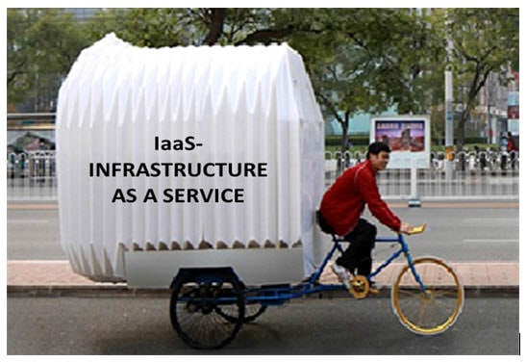](https://www.guru99.com/images/blog_image/cloud_computing_7.jpg)

**IaaS(Infrastructure as a service)**is a complete package for computing. For small scale businesses who are looking for cutting cost on IT infrastructure, IaaS is one of the solutions. Annually a lot of money is spent in maintenance and buying new components like hard-drives, network connections, external storage device etc. which a business owner could have saved for other expenses by using IaaS.

## Grid Computing Vs Cloud Computing

When we switch on the fan or any electric device, we are less concern about the power supply from where it comes and how it is generated. The power supply or electricity that we receives at our home travels through a chain of network, which includes power stations, transformers, power lines and transmission stations. These components together make a ‘Power Grid’. Likewise, ‘Grid Computing’ is an infrastructure that links computing resources such as PCs, servers, workstations and storage elements and provides the mechanism required to access them.

[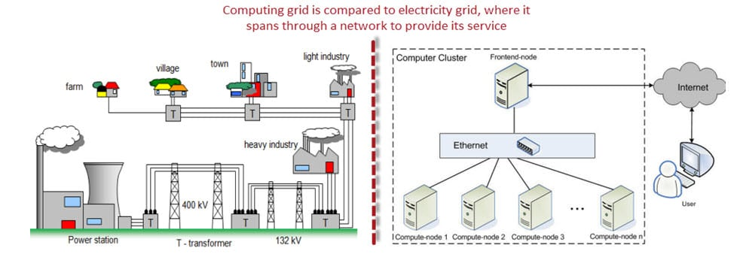](https://www.guru99.com/images/blog_image/cloud_computing_9.jpg)

Grid Computing is a middle ware to co-ordinate disparate IT resources across a network, allowing them to function as whole. It is more often used in scientific research and in universities for educational purpose. For example, a group of architect students working on a different project requires a specific designing tool and a software for designing purpose but only couple of them got access to this designing tool, the problem is how they can make this tool available to rest of the students. To make available for other students they will put this designing tool on campus network, now the grid will connect all these computers in campus network and allow student to use designing tool required for their project from anywhere.

Cloud computing and Grid computing is often confused, though there functions are almost similar there approach for their functionality is different. Let see how they operate-

| **Cloud Computing** | **Grid Computing** |
| --- | --- |
| Cloud computing works more as a service provider for utilizing computer resource | Grid computing uses the available resource and interconnected computer systems to accomplish a common goal |
| Cloud computing is a centralized model | Grid computing is a decentralized model, where the computation could occur over many administrative model |
| Cloud is a collection of computers usually owned by a single party. | A grid is a collection of computers which is owned by a multiple parties in multiple locations and connected together so that users can share the combined power of resources |
| Cloud offers more services all most all the services like web hosting, DB (Data Base) support and much more | Grid provides limited services |
| Cloud computing is typically provided within a single organization (eg : Amazon) | Grid computing federates the resources located within different organization. |

**Utility Computing Vs Cloud Computing**

In our previous conversation in “Grid Computing” we have seen how electricity is supplied to our house, also we do know that to keep electricity supply we have to pay the bill. Utility Computing is just like that, we use electricity at home as per our requirement and pay the bill accordingly likewise you will use the services for the computing and pay as per the use this is known as ‘Utility computing’. Utility computing is a good source for small scale usage, it can be done in any server environment and requires Cloud Computing.

[](https://www.guru99.com/images/blog_image/cloud_computing_10.jpg)

Utility computing is the process of providing service through an on-demand, pay per use billing method. The customer or client has access to a virtually unlimited supply of computing solutions over a virtual private network or over the internet, which can be sourced and used whenever it’s required. Based on the concept of utility computing , grid computing, cloud computing and managed IT services are based.

Through utility computing small businesses with limited budget can easily use software like CRM (Customer Relationship Management) without investing heavily on infrastructure to maintain their clientele base.

| **Utility Computing** | **Cloud Computing** |
| --- | --- |
| Utility computing refers to the ability to charge the offered services, and charge customers for exact usage | Cloud Computing also works like utility computing, you pay only for what you use but Cloud Computing might be cheaper, as such, Cloud based app can be up and running in days or weeks. |
| Utility computing users want to be in control of the geographical location of the infrastructure | In cloud computing, provider is in complete control of cloud computing services and infrastructure |
| Utility computing is more favorable when performance and selection infrastructure is critical | Cloud computing is great and easy to use when the selection infrastructure and performance is not critical |
| Utility computing is a good choice for less resource demanding | Cloud computing is a good choice for high resource demanding |
| Utility computing refers to a business model | Cloud computing refers to the underlying IT architecture |

**Security concerns for Cloud Computing**

While using cloud computing, the major issue that concerns the users is about its security.

One concern is that cloud providers themselves may have access to customer’s unencrypted data- whether it’s on disk, in memory or transmitted over the network.

[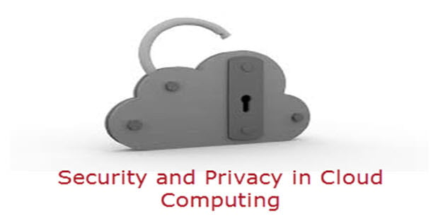](https://www.guru99.com/images/blog_image/cloud_computing_11.jpg)

Some countries government may decide to search through data without necessarily notifying the data owner, depending on where the data resides, which is not appreciated and is considered as a privacy breach (Example Prism Program by USA).

To provide security for systems, networks and data cloud computing service providers have joined hands with TCG ( Trusted Computing Group) which is non-profit organization which regularly releases a set of specifications to secure hardware, create self-encrypting drives and improve network security. It protects the data from root kits and malware.

As computing has expanded to different devices like hard disk drives and mobile phones, TCG has extended the security measures to include these devices. It provides ability to create a unified data protection policy across all clouds.

Some of the trusted cloud services are Amazon, Box.net, Gmail and many others.

**Privacy Concern & Cloud Computing**

Privacy present a strong barrier for users to adapt into Cloud Computing systems

There are certain measures which can improve privacy in cloud computing.

1. The administrative staff of the cloud computing service could theoretically monitor the data moving in memory before it is stored in disk. To keep the confidentiality of a data, administrative and legal controls should prevent this from happening.
2. The other way for increasing the privacy is to keep the data encrypted at the cloud storage site, preventing unauthorized access through the internet; even cloud vendor can’t access the data either.

**Summary**

* Cloud Computing is defined as storing and accessing data and computing services over the Internet.
* The term “Cloud” came from a network design used by network engineers to represent the location of various network devices and their interconnection.
* Today many large and small-scale businesses thrive on their data & they spend a huge amount of money to maintain this data.
* Cloud computing architecture helps organizations to lower their IT infrastructure and computer costs per user.
* Four Types of Cloud are 1) Private, 2) Community, 3) Public, and 4) Hybrid.
* Important Cloud Computing Services are 1) Software as a Service (SaaS), 2) Platform as a Service (PaaS), and 3) Infrastructure as a Service (IaaS).
* Grid Computing is a middleware to coordinate disparate IT resources across a network, allowing them to function as a whole.
* Utility computing is the process of providing service through an on-demand, pay-per-use billing method.
* Privacy is a strong barrier for users to adapt Cloud Computing systems.

# Cloud Computing Architecture and Components

## What is Cloud Computing Architecture?

Cloud Computing Architecture is a combination of components required for a Cloud Computing service. A Cloud computing architecture consists of several components like a frontend platform, a backend platform or servers, a network or Internet service, and a cloud-based delivery service.

Let’s have a look into Cloud Computing and see what Cloud Computing is made of. Cloud computing comprises two components, the front end, and the back end. The front end consists of the client part of a cloud computing system. It comprises interfaces and applications that are required to access the Cloud computing or Cloud programming platform.

[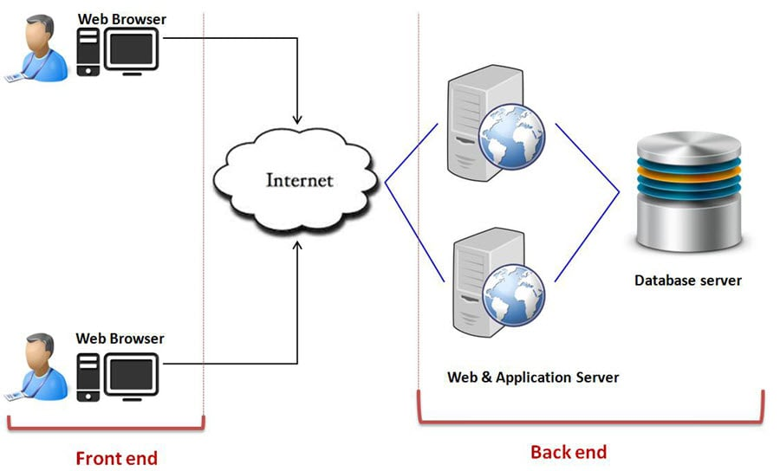](https://www.guru99.com/images/blog_image/cloud_computing_8.jpg)Cloud Computing Architecture

While the back end refers to the cloud itself, it comprises the resources required for cloud computing services. It consists of virtual machines, servers, data storage, security mechanisms, etc. It is under the provider’s control.

Cloud computing distributes the file system that spreads over multiple hard disks and machines. Data is never stored in one place, and in case one unit fails, the other will take over automatically. The user disk space is allocated on the distributed file system, while another important component is an algorithm for resource allocation. Cloud computing is a strong distributed environment, and it heavily depends upon strong algorithms.

## Cloud Computing Architecture

The Architecture of Cloud computing contains many different components. It includes Client infrastructure, applications, services, runtime clouds, storage spaces, management, and security. These are all the parts of a Cloud computing architecture.

**Front End:**

The client uses the front end, which contains a client-side interface and application. Both of these components are important to access the Cloud computing platform. The front end includes web servers (Chrome, Firefox, Opera, etc.), clients, and mobile devices.

**Back End:**

The backend part helps you manage all the resources needed to provide Cloud computing services. This Cloud architecture part includes a security mechanism, a large amount of data storage, servers, virtual machines, traffic control mechanisms, etc.

[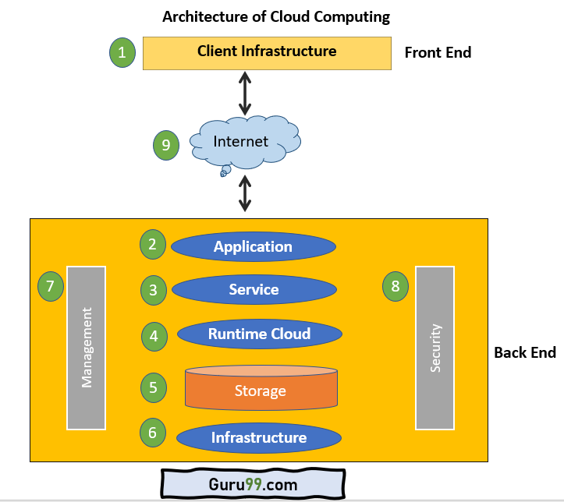](https://www.guru99.com/images/cloud-computing-architecture-diagram.png)Cloud Computing Architecture Diagram

## Important Components of Cloud Computing Architecture

Here are some important components of Cloud computing architecture:

### 1. Client Infrastructure

Client Infrastructure is a front-end component that provides a GUI. It helps users to interact with the Cloud.

### 2. Application

The application can be any software or platform which a client wants to access.

### 3. Service

The service component manages which type of service you can access according to the client’s requirements.

Three Cloud computing services are:

* Software as a Service (SaaS)
* Platform as a Service (PaaS)
* Infrastructure as a Service (IaaS)

### 4. Runtime Cloud

Runtime cloud offers the execution and runtime environment to the virtual machines.

### 5. Storage

Storage is another important Cloud computing architecture component. It provides a large amount of storage capacity in the Cloud to store and manage data.

### 6. Infrastructure

It offers services on the host level, network level, and application level. Cloud infrastructure includes hardware and software components like servers, storage, network devices, virtualization software, and various other storage resources that are needed to support the cloud computing model.

### 7. Management

This component manages components like application, service, runtime cloud, storage, infrastructure, and other security matters in the backend. It also establishes coordination between them.

### 8. Security

Security in the backend refers to implementing different security mechanisms for secure Cloud systems, resources, files, and infrastructure to the end-user.

### 9. Internet

Internet connection acts as the bridge or medium between frontend and backend. It allows you to establish the interaction and communication between the frontend and backend.

## Benefits of Cloud Computing Architecture

Following are the cloud computing architecture benefits:

* Makes the overall Cloud computing system simpler.
* Helps to enhance your data processing.
* Provides high security.
* It has better disaster recovery.
* Offers good user accessibility.
* Significantly reduces IT operating costs.

## Virtualization and Cloud Computing

The main enabling technology for Cloud Computing is Virtualization. Virtualization is the partitioning of a single physical server into multiple logical servers. Once the physical server is divided, each logical server behaves like a physical server and can run an operating system and applications independently. Many popular companies like VMware and Microsoft provide virtualization services. Instead of using your PC for storage and computation, you can use their virtual servers. They are fast, cost-effective, and less time-consuming.

For software developers and testers, virtualization comes in very handy. It allows developers to write code that runs in many different environments for testing.

Virtualization is mainly used for three main purposes: 1) Network Virtualization, 2) Server Virtualization, and 3) Storage Virtualization

**Network Virtualization:** It is a method of combining the available resources in a network by splitting up the available bandwidth into channels. Each channel is independent of others and can be assigned to a specific server or device in real time.

**Storage Virtualization:** It is the pooling of physical storage from multiple network storage devices into what appears to be a single storage device that is managed from a central console. Storage virtualization is commonly used in storage area networks (SANs).

**Server Virtualization:** Server virtualization is the masking of server resources like processors, RAM, operating system, etc., from server users. Server virtualization intends to increase resource sharing and reduce the burden and complexity of computation from users.

Virtualization is the key to unlock the Cloud system, what makes virtualization so important for the cloud is that it decouples the software from the hardware. For example, PCs can use virtual memory to borrow extra memory from the hard disk. Usually, a hard disk has a lot more space than memory. Although virtual disks are slower than real memory, if managed properly, the substitution works perfectly. Likewise, there is software that can imitate an entire computer, which means 1 computer can perform the functions equals to 20 computers. This concept of virtualization is a crucial element in various types of cloud computing, which you can learn more about in this comprehensive guide.

## Summary

* Cloud Computing Architecture is a combination of components required for a Cloud Computing service.
* The front-end part is used by the client that contains client-side interfaces and applications, which are important to access the Cloud computing platforms.
* The service provider uses the back-end part to manage all the needed resources to provide Cloud computing services.
* Components of Cloud Computers are 1) Client Infrastructure, 2) Application, 3) Service, 4) Runtime Cloud, 5) Storage, 6) Infrastructure, 7) Management, 8) Security, and 9) Internet.
* Cloud computing makes a complete Cloud computing system simpler.
* Virtualization is the partitioning of a single physical server into multiple logical servers.

# Characteristics of Cloud Computing: Essential Features

By :[Richard Peterson](https://www.guru99.com/author/richard)Richard Peterson

UpdatedSeptember 1, 2023

## On-demand self-service

Cloud computing delivers on-demand service. It provides the feature of monitoring server uptime with computing capabilities to the end-users. Cloud computing provides pre-defined network storage that enables the end-users to monitor their computing capabilities. Cloud computing works on a self-service model.

They help end-users to make better decisions as they know how to use cloud computing services.

The Essential Characteristics of Cloud Computing are:

**Table of Content:**

Let’s discuss them in detail:

## Multi-tenancy and resource pooling

One of the most important features of cloud technology is multi-tenancy. It can be defined as the software architecture that enables the single program instance to provide services to multiple end-users. This feature enables the usage of the same computing resources by multiple customers.

## Broad network access

Cloud computing is achieved through standard computing mechanisms, and this feature helps promote heterogeneous thick and thin client platforms.

Examples of such platforms comprise mobile phones, laptops, dedicated workstations, and tablets. The capabilities are delivered across multiple networks. Cloud computing, therefore, helps break barriers and boundaries as they function across multiple geographies.

## Rapid elasticity and scalability

The cloud computing capabilities can be released elastically. It enables you to scale the cloud computing services inward and outward, and it helps to be commensurate with the dynamic demand posted by the end-users.

## Resource pooling

Cloud computing delivers affordable resource pooling solutions. With resource pooling, organizations can reduce substantial computing costs, and it helps in the dynamic pooling of resources that enable them to deliver computing services to several consumers.

## Measured and reporting service

Cloud systems offer the metering capability to monitor, control, and optimize the usage of cloud resources. This feature can be defined as a measured service.

The metering capability is placed at some level of the abstraction of applicable services. Therefore, this feature enables transparency for both the provider of service and the consumer.

## Automation

Through automation, IT teams and developers maintain and modify cloud services. When cloud infrastructure is in place, it ensures minimum interaction from humans. All the configurations are installed to ensure the monitoring and maintenance of cloud computing services, and such configurations are mostly automated. Therefore, automation in cloud computing facilitates the faster expansion of cloud services.

## Resilience

Cloud computing delivers continuous server uptime, and hence it offers resilient services. It offers the capability to recover from any service interruption. The cloud service provider also develops strategies that boost disaster management, achieved by maintaining backup cloud nodes.

## Large Network Access

Cloud computing is so versatile that it enables its users to access cloud services. These fundamental characteristics of Cloud Computing also enable them to upload data to the cloud from anywhere. For this, you need to have a decent internet connection and a robust device that helps make a connection to the cloud.

## Work from any location

Cloud computing promotes the feature of remote working. It helps the end-user function, work, or deliver remote services from any location. Users are therefore able to access company data even on their smartphones or through laptops. It also enables users to connect with one another quickly.

## Comfortable payment structure

Cloud computing offers a flexible payment structure that plays an important role in the cost-cutting of organizations. Pricing varies based on the features and functionalities chosen by a customer.

The payment options provided by the cloud service providers to the end-users are very simple and streamlined, which aides them in saving on substantial costs and time.

## Service Excellence

Cloud computing delivers end-users with a wide range of services. The cloud service providers share end users’ service level agreements with their clients.

It also provides documentation on how they would achieve continuous availability and bandwidth of their clients’ services.

## Easy maintenance

Easy maintenance is one of the critical features of cloud computing. The client is never involved in maintenance-related services. Its managed by the cloud computing provider. The maintenance services are so well planned that the downtime remains significantly low. Moreover, the cloud undergoes regular updates that help in capability optimization.

## Flexibility

The end-users benefit from the flexibility offered by the cloud services when they host data in the dedicated cloud. This ensures that the end-users can do away from traditional hosting techniques wherein they had to change or switch the service providers more frequently.

## Economical and Security

This feature is one of the key aspects of cloud computing. It helps the big organizations to save a substantial amount on IT-related expenditure. You need to pay a small fee to the third-party providers to ensure that the cloud space is adequately administered and maintained. This also helps in boosting security in exchange for a nominal fee.

## Availability

Cloud computing offers highly resilient services, and the cloud services are available for 24 x7 duration if the cloud resource faces downtime, the system recovers and starts within no time.

While the cloud service makes a recovery, information stored in servers, networks, and databases remains to be secured. Since cloud services can be accessed from any geographical location, their services remain available most of the time.

# Advantages and Disadvantages of Cloud Computing

By :[Richard Peterson](https://www.guru99.com/author/richard)Richard Peterson

UpdatedSeptember 1, 2023

## What is Cloud Computing?

Cloud computing is a term referred to storing and accessing data over the internet. It doesn’t store any data on the hard disk of your personal computer. In cloud computing, you can access data from a remote server.

Now, we will learn the advantages and disadvantages of Cloud Computing.

**Table of Content:**

## Advantages of Cloud Computing

Here, we will learn what are the benefits of Cloud Computing in your organization:

[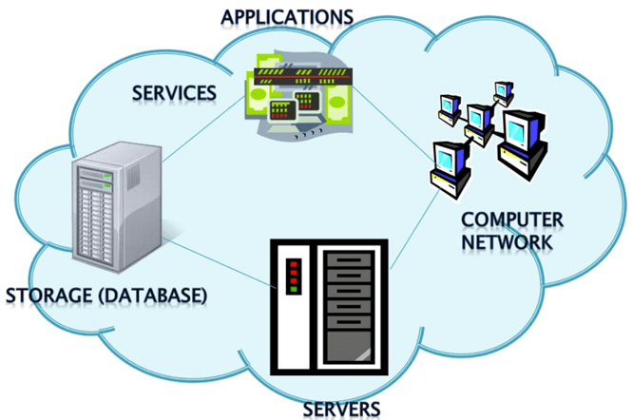](https://www.guru99.com/images/1/031519_0703_Advantagesa1.png)Cloud Computing Overview

### Cost Savings

Cost saving is one of the biggest Cloud Computing benefits. It helps you to save substantial capital cost as it does not need any physical hardware investments. Also, you do not need trained personnel to maintain the hardware. The buying and managing of equipment is done by the cloud service provider.

### Strategic edge

Cloud computing offers a competitive edge over your competitors. It is one of the best advantages of Cloud services that helps you to access the latest applications any time without spending your time and money on installations.

### High Speed

Cloud computing allows you to deploy your service quickly in fewer clicks. This faster deployment allows you to get the resources required for your system within fewer minutes.

### Back-up and restore data

Once the data is stored in a Cloud, it is easier to get the back-up and recovery of that, which is otherwise very time taking process on-premise.

### Automatic Software Integration

In the cloud, software integration is something that occurs automatically. Therefore, you don’t need to take additional efforts to customize and integrate your applications as per your preferences.

### Reliability

Reliability is one of the biggest benefits of Cloud hosting. You can always get instantly updated about the changes.

### Mobility

Employees who are working on the premises or at the remote locations can easily access all the could services. All they need is an Internet connectivity.

### Unlimited storage capacity

The cloud offers almost limitless storage capacity. At any time you can quickly expand your storage capacity with very nominal monthly fees.

### Collaboration

The cloud computing platform helps employees who are located in different geographies to collaborate in a highly convenient and secure manner.

### Quick Deployment

Last but not least, cloud computing gives you the advantage of rapid deployment. So, when you decide to use the cloud, your entire system can be fully functional in very few minutes. Although, the amount of time taken depends on what kind of technologies are used in your business.

### Other Important Benefits of Cloud Computing

Apart from the above, some other Cloud Computing advantages are:

* On-Demand Self-service
* Multi-tenancy
* Offers Resilient Computing
* Fast and effective virtualization
* Provide you low-cost software
* Offers advanced online security
* Location and Device Independence
* Always available, and scales automatically to adjust to the increase in demand
* Allows pay-per-use
* Web-based control & interfaces
* API Access available.

## Disadvantages of Cloud Computing

Here, are significant challenges of using Cloud Computing:

[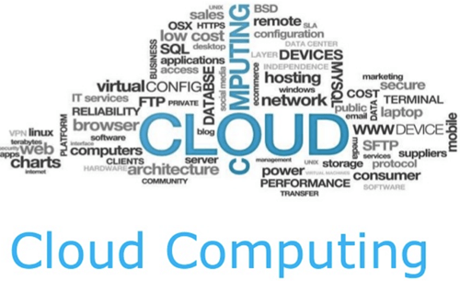](https://www.guru99.com/images/1/031519_0703_Advantagesa2.png)

### Performance Can Vary

When you are working in a cloud environment, your application is running on the server which simultaneously provides resources to other businesses. Any greedy behavior or DDOS attack on your tenant could affect the performance of your shared resource.

### Technical Issues

Cloud technology is always prone to an outage and other technical issues. Even, the best cloud service provider companies may face this type of trouble despite maintaining high standards of maintenance.

### Security Threat in the Cloud

Another drawback while working with cloud computing services is security risk. Before adopting cloud technology, you should be well aware of the fact that you will be sharing all your company’s sensitive information to a third-party cloud computing service provider. Hackers might access this information.

### Downtime

Downtime should also be considered while working with cloud computing. That’s because your cloud provider may face power loss, low internet connectivity, service maintenance, etc.

### Internet Connectivity

Good Internet connectivity is a must in cloud computing. You can’t access cloud without an internet connection. Moreover, you don’t have any other way to gather data from the cloud.

### Lower Bandwidth

Many cloud storage service providers limit bandwidth usage of their users. So, in case if your organization surpasses the given allowance, the additional charges could be significantly costly

### Lacks of Support

Cloud Computing companies fail to provide proper support to the customers. Moreover, they want their user to depend on FAQs or online help, which can be a tedious job for non-technical persons.

## Conclusion

Despite all the Cloud Computing advantages and disadvantages, we can’t deny the fact that Cloud Computing is the fastest growing part of network-based computing. It offers a great advantage to customers of all sizes: simple users, developers, enterprises and all types of organizations. So, this technology here to stay for a long time. To gain a better understanding of the various types of cloud computing and their benefits, check out this informative article.

# Cloud Computing Applications: Real-World Examples

Cloud Computing Services can be used by an individual for personal needs or by a company/enterprise. Data can be stored on the cloud rather than storing it in local memory. Cloud computing also delivers an array of remote-based applications or solutions. It plays a huge role in terms of optimizing business resources. Let’s look into various real-world examples and applications of Cloud Computing.

## Applications of Cloud Computing

Here are some important Cloud Computing applications:

### Art Applications

Cloud computing services deliver several art applications. Such applications can be used for designing attractive books, cards, and creative images. They help in making instant creative designs. These designs can then be used for creating and printing mini cards. It also provides professional editing services. It can be configured or installed as simple desktop apps on the personal computers of designers.

**Examples:**

Vistaprint and Adobe Creative Cloud are top examples of cloud-based art applications or services. These applications help designers edit existing designs.

### File Storage Platform

The online file storage platform is an example of a cloud application. There are several online file storage platforms that enable the end-users to host files, documents, videos, and images on the cloud.

These applications provide end-users with a simple user interface to use, view and upload documents from their local personal computer to these sites. Such cloud computing services can be accessed for free and paid. When end-users pay a monthly or annual subscription fee, they can access premium services.

**Examples:**

Examples of online file storage platforms comprise of Media Fire, Hot file, and Rapid share.

### Image Editing Applications

Many cloud services provide end-users with free editing services for pictures. This cloud service offers image resizing, editing, cropping, and special effects under one common graphic user interface. In addition to the above services, the cloud services offer contrast and brightness editable applications.

The cloud service application delivers high-level, complex features for payment of subscription fees. They are customized so that they are easy to use for end-users.

**Examples:**

Popular examples of image editing cloud applications are Fotor and Adobe creative cloud.

### Data Storage Application

Nowadays cloud computing model offers several data storage applications. It enables the end-users to store information in the cloud. Such clouds could be either a public cloud or a private cloud.

You can store data, files, and images on such clouds. By doing so, cloud computing allows information sharing and collaboration. The data stored on the cloud can be secured and backed up instantly. The cloud storage services provide data format conversion services.

**Examples:**

Examples of data storage applications comprise DropBox, OneDrive, Box, Mozy, and Google suites.

### Antivirus Application

The cloud services also provide antivirus and support services. It helps you to boost the smooth functioning of the system. Cloud antivirus software help end-users clean the system at periodic intervals.

They allow you to detect or identify and then fix the threats caused by malware and some form of viruses. Due to the availability of such features, they benefit the end-users in several ways. Such applications are offered free of cost. They detect the threat and send a report to the data center of the cloud, which in turn helps fix the issue for the end-users.

**Examples:**

Popular examples of Cloud antivirus software include Kaspersky endpoint protection and Sophos endpoint protection.

### Entertainment Applications

The cloud service providers give a multi-cloud strategy. It helps facilitate the interaction of entertainment applications with the targeted audience. It comprises online gaming and entertainment services.

**Examples:**

Google stadia, it is a cloud gaming service that provides a video gaming experience at 4K resolution and within 60 frames. Project Atlas is one of the top examples of cloud entertainment apps.

These apps help online gamers establish an instant and smooth connection and experience a smooth virtual gaming environment.

ADVERTISING

### URL Conversion Application

Several cloud services offer URL shortening services. The URL shortening services look in terms of converting long-sized URLs to short-sized URLs. Many cloud-based social media applications offer URL shortening or conversion services.

They also help secure applications from malware services and hacking services. Such cloud platforms promote or boost the easy management of URLs. Here URL is an abbreviation that stands for uniform resource locator.

**Examples:**

One of the key examples is that of the Bitly. This application helps you to create short URLs that help redirect the original website. Such applications also support microblogging.

### Meeting Applications

Most cloud computing services offer virtual servers that facilitate go-to-meeting facilities. They offer video conferencing and other meeting applications. Such cloud computing applications enable the end-users to initiate meetings virtually.

This can be initiated for both personal and professional requirements. The services help end-users to connect with other individuals within seconds. To boost collaboration, they also offer screen sharing and presentation sharing facilities.

**Examples:**

Zoom and GoTo meetings are some of the key applications of cloud-based meeting applications. They offer smooth video conferencing and cloud-based presentation services.

### Presentation Application

There are specific cloud-based applications that help the end-users to create formal presentations. They also provide storage space to keep new and existing formal presentations. These apps also enable the end-users to access their presentations from anywhere globally.

**Examples:**

Slide Rocket is one of the premier cloud computing applications. It helps end-users to draft and customize formal presentations.

### Social Media Application

Several cloud-based social media applications allow users to connect on a real-time basis. They also provide an interface to collaborate.

This can be done from anywhere across the globe. Every minute, these applications allow millions of end-users to connect simultaneously.

**Examples:**

The cloud-based applications that allow millions of users to connect on a real-time basis are Facebook, Yammer, Twitter, and LinkedIn.

They enable the end-users to share videos, images, stories, and experiences. It drives real-time and personalized engagements across different locations.

### GPS Application

One of the critical advancements in cloud computing services is providing GPS-enabled services for the end-users. The GPS helps in the facilitation of navigational services on a real-time basis.

GPS is an abbreviation that stands for the Global Positioning System. Using an internet connection, the users use this application to get guidance on the directions as presented on the map and this, in turn, helps in finding locations.

**Examples:**

The top examples of cloud-based GPS services constitutes Google maps and Yahoo maps. These are open source and free-to-use applications. GPS-based services are used by millions of people across the globe.

### Accounting Application

There is a new cloud-based accounting application that helps in accounting-related tasks of the business or an organization. Such applications help the end-users to track real-time expenses and, in turn, manage profit-and-loss statements on a real-time basis.

**Examples:**

One of the best examples of cloud-based accounting applications is Outright. Some other examples are Zoho books and Kash flow.

### Management Application

Project management applications help the end-users to document and share notes on a real-time basis with multiple stakeholders. This aids in project management as stakeholders can access the notes prepared and saved in one location to refer out their tasks.

These are offered on a free-to-use basis as well as with premium features. The premium features can be accessed once the user pays a one-time subscription fee. These applications can be used to meet the end-user’s business and personal requirements.

**Example:**

The cloud services also provide management-related applications such as Evernote.

### E-commerce Application

Cloud computing services also have made substantial inroads in offering e-commerce services. There are several cloud-based e-commerce applications that helps in driving smooth and accessible business requirements of the e-commerce business. Such applications come with dynamic tracking mechanisms that help in the order tracking processes.

It monitors the order received along with the order delivered status. It further helps the business owners to know the tracking costs, refund rate on orders, and damage rate to the business.

Such applications help the business owners save substantial time and effort in the tracking process. There are no hard costs involved in terms of managing such applications.

**Examples:**

One of the best examples of cloud-based e-commerce applications is Amazon, eBay, etc.

### Software as a service application (SAAS)

Software-as-a-service is one of the critical applications for cloud computing. The SAAS-based products help in the distribution of data online. These applications can be accessed from a browser opened on any device.

The products under SAAS offer ease of use with upfront subscription-based pricing. It additionally offers the lowest cost options.

**Examples:**

One of the best examples of SAAS-based products is Stream native and Atlassian. They enable the business to organize and process the data with good execution speed. Atlassian offers a more workflow-based solution. Other examples of SAAS Applications are Salesforce, Hubspot, stack, etc.

### Infrastructure as a service (IAAS)

The infrastructure as a service application delivers a virtualized computing environment. The environment is managed over the internet. They have broader applications in application development and testing the applications.

They ensure that the business continuity is maintained. Hence it has become a popular choice for several organizations.

**Examples:**

Finix is one of the critical examples of IAAS. It provides a platform that companies and businesses can use to streamline their in-house payment process. They enable gateway and tokenization with merchant onboarding. It further helps in providing reporting mechanisms such as delivering settlement and chargeback reports.

The digital ocean is another example of IAAS. It helps businesses to create multiple virtual machines within seconds. It helps them manage and scale their products effectively as they can scale data storage based on the incoming traffic.

### Platform as a service application (PAAS)

This can be categorized as the cloud computing model that offers users application management capabilities. They provide virtual resources that help businesses build, deploy, and launch their applications into the virtual environment. They enable outsourcing of database security, hosting, and data storage that enable long-term investments.

**Examples:**

Pager duty is one of PAAS examples, which helps the business perform incident management. The business can monitor the newly created incidents on a real-time base. They also help in terms of data collection and distribution of tasks.

### Data Governance and Cyber Security

This Application looks in terms of delivering cloud-based security. By using this Application, the organization can secure a lot of sensitive data. They outsmart hackers and ensure that any type of invasion of their organizational data is entirely curbed.

**Examples:**

Z-Scalar generally functions as a zero-trust platform. It can connect the users remotely with any device or application present over any network. It promotes a versatile and secure remote workplace.

Carbonite cloud is another example of a cloud-based cyber security feature that protects sensitive data and information from potential ransomware. It essentially works towards reducing security breaches. Forcepoint is another example that is a cloud-based solution that offers cybersecurity-related functions to organizations.

### Back-up and recovery

The cloud provider and the vendor offer data backup and security services. This helps the data be backed properly and helps secure data. If data is lost, they also have recovery solutions that help faster data recovery.

The traditional methods of data recovery could become a complex problem. Sometimes retrieving lost data could be cumbersome. However, cloud computing eliminates such limitations and promotes robust data recovery and backup solutions.

**Examples:**

Examples of backup and recovery solutions include Idrive personal, Backblaze, and CrashPlan for small businesses.

### Testing and development

Cloud computing provides platforms that help in real-time testing and the development of IT-enabled resources. They ensure that the IT-enabled resources are ready to be used to deliver services.

Such services are offered cheap and are not all expensive. This, in turn, helps the organizations to develop scalable and flexible IT products or services to drive the best solutions.

**Examples:**

Cloud-based testing and development examples comprise SOASTA CloudTest, Load storm, and BlazeMeter.

### Big Data Analytics

Cloud computing services offer solutions that help in the churning and managing of big data. Big data is a collection of data growing each day exponentially and generally presents the characteristics of having huge volumes.

It comprises data that is of considerable complexity and size. Traditional computing mechanisms offers limited to no solutions to handle and manage big data. Cloud computing offers solutions that help manage big data and eliminate the need to have physical stores.

Additionally, cloud computing offers big data analytics that helps in driving the analysis of big raw data. This helps organizations to make decisions on a quickly basis and focuses on the insights shared from cloud services.

**Examples:**

Examples of cloud-based big data solutions are driven by Hana, Hadoop, Apache, etc.

### Education Application

Cloud computing has become so advanced that they also offer remote-based e-learning applications. It has enabled educational institutions to develop online distance learning platforms.

It helps in facilitating online education. The cloud services also provide remote student information systems. Students from any location can access it.

Such systems allow students to track and monitor their overall performance in school. It has made the learning experience more engaging and attractive for teachers, researchers, and students.

The educational institutions also have saved substantial money to maintain the physical infrastructure costs.

Further, to boost remote learning and engagement, each student and faculty member are provided with their own dedicated space secured by their user credentials. This ensures that data can be accessed from anywhere.

**Examples:**

Examples of cloud-based educational applications comprise Canvas, Coursera, blackboard, and Google Classroom.

## Summary

* Cloud computing offers an array of services by avoiding the need for physical storage systems.
* It can be used daily by the installation of a secure internet connection.
* They offer online data storage, backup solutions, and big data analytics.
* They help in facilitating remote working and remote learning at minimal costs.
* They deliver on-demand cloud computing services with productive use of cloud computing resources.
* They help create and check the new application in their virtual test and development environment.
* They offer several software such as Microsoft Azure that offers productive use of resources and offer strong computing power.
* They don’t set physical storage systems for existing infrastructure.

# Types of Cloud Computing – Public, Private, Hybrid & Community

Cloud computing is essentially an assortment of IT infrastructure services various providers offer. Reduced costs and improved resilience make it a viable solution for many IT needs.

Not all cloud solutions are the same. There are some key differences in deployment that businesses need to understand to choose the right cloud solution for their unique needs, as the deployment model can impact the cost as well as the capabilities of a cloud architecture.

## Types of Cloud

Let’s take a closer look at the four main types of cloud computing, including

1. Public Cloud
2. Private Cloud
3. Hybrid Cloud
4. Community Cloud

[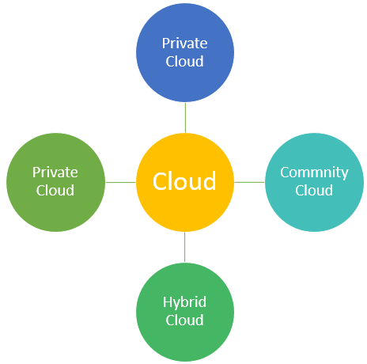](https://www.guru99.com/images/3/cloud-deployment-models-1.png)Types of Cloud Computing

## Public Cloud

The public cloud is a model where a third-party provider owns computing resources and makes these resources available to users. While the subscription model is common, there are free public cloud services.

They offer additional tools to help users get more out of their cloud architecture, including cloud-based apps, data storage, and more. Some public cloud service providers also offer a development environment where users can deploy their own apps.

A common use of public cloud services is to deploy virtual machines. Virtual machines allow you to build a customizable infrastructure with the OS of your choice. It also facilitates remote work by making your work environment accessible from anywhere.

It’s an on-demand model where a third-party cloud service provider can deliver customized solutions based on the needs of each user. At the same time, the providers can pool resources to accommodate the needs of a large group of users.

[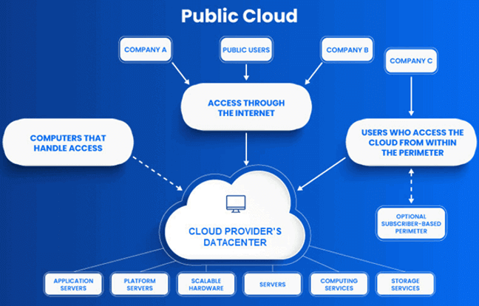](https://www.guru99.com/images/3/cloud-deployment-models.png)

| **Pros** | **Cons** |
| --- | --- |
| It’s a scalable model where users can add or remove resources as needed. | Relying on a third-party cloud provider gives you minimal visibility over the back-end process. |
| Pooled resources help keep the cost down, and most providers have flexible pricing models. | Not ideal for resource-intensive applications that require dedicated servers to run properly. |
| Offer built-in backup solutions to facilitate recovery. |  |
| Public cloud environments are a viable solution for businesses with limited IT teams and internal resources. |  |
| Major companies like Amazon or Microsoft offer reliable public cloud services and innovative business solutions. |  |

## Private Cloud

Private cloud models leverage the advantages of on-premises hosting while giving you access to the flexibility of a cloud-based architecture. It’s a flexible model where you can decide how much of your architecture you want to outsource.

This cloud computing model is used exclusively by a particular organization and never shared with other organizations. Some cloud service providers also offer services to manage private clouds, including handling app deployments, security, updates, and other aspects of managing your IT infrastructure.

[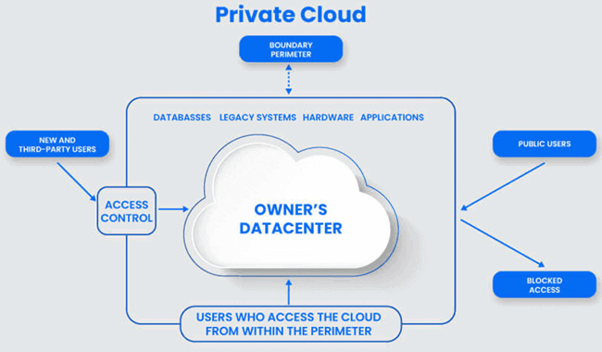](https://www.guru99.com/images/3/cloud-deployment-model-3.png)

Private cloud infrastructure can be a good match for businesses that must meet strict industry requirements regarding data handling and privacy. It also ensures that resource-intensive applications have the computing resources needed to run as expected.

| **Pros** | **Cons** |
| --- | --- |
| Managing your software and hardware resources yourself gives you complete freedom. | A private cloud architecture comes with a significant upfront cost if you purchase hosting hardware. |
| There are no limits over the number or type of apps that you can deploy in the private cloud. | Building a private cloud infrastructure can be complex due to the number of options available. |
| You can protect your entire cloud environment behind a firewall that you control. |  |
| Owning your cloud architecture hardware can increase the valuation of your business and protect you from potential fluctuations in subscription prices. |  |

## Hybrid Cloud

A hybrid cloud deployment model uses public and private infrastructure elements. It’s a flexible model that allows you to leverage benefits from these two deployment models.

A hybrid environment can help cut costs if your needs and requirements vary from one process to another. Sensitive data, legacy systems, and apps that require a configuration not supported by the public cloud service provider may remain in the private portion of the architecture. Moreover, workloads that require more bandwidth and SaaS solutions can run on a public cloud server.

The public and private elements of the infrastructure can communicate with each other, and exchange data as needed.

Nowadays, more and more businesses are using hybrid cloud infrastructure. Many of these businesses rely on third-party providers for applications that don’t require advanced security measures or a specific environment.

| **Pros** | **Cons** |
| --- | --- |
| It can facilitate the transition from a public to a private cloud or the other way around. | Hybrid infrastructures can become complex and challenging to manage if you have too many elements. |
| It lowers your deployment time and allows you to leverage public resources to add new capabilities to your IT infrastructure. | Managing the private portion of your architecture can be expensive. |
| A scalable hybrid cloud gives you access to more public resources as needed. |  |
| You don’t have to compromise your security or regulatory requirements. |  |

## Community Cloud

The community cloud model is relatively recent. This deployment model is similar to the public cloud but solves issues linked to implementing a one-size-fits-all model.

The cloud provider creates an environment that meets your unique needs by adjusting the server configuration, implementing cybersecurity solutions, or following specific data storage requirements.

[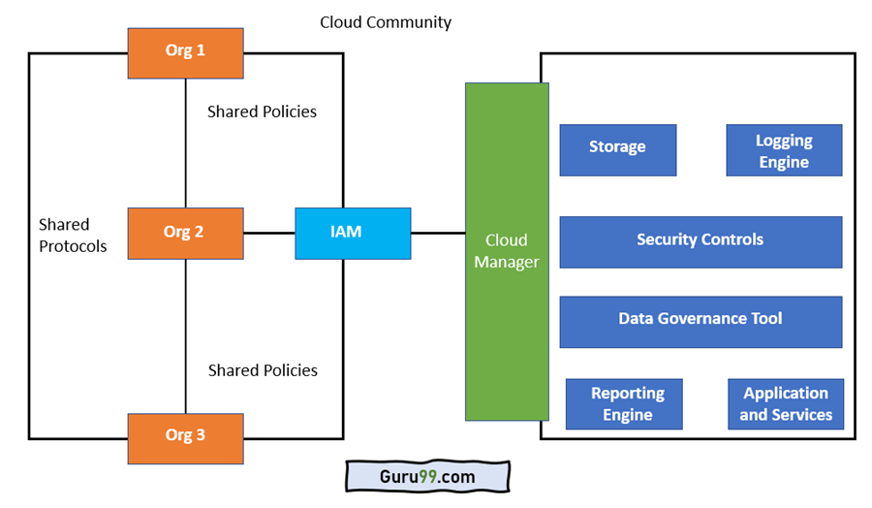](https://www.guru99.com/images/3/community-cloud-1.png)

As community cloud continues to grow in popularity, finding a solution that matches your needs will become easier. Businesses in industries like finance, insurance, healthcare, or the legal field can already choose from a wide range of community cloud solutions.

| **Pros** | **Cons** |
| --- | --- |
| This cloud platform gives you more visibility and control over your cloud environment. | Community cloud is relatively recent, and not all providers offer this model. |
| The community cloud is compatible with a hybrid architecture if you want to retain some elements of a private cloud model. | Its price is higher compared to a traditional public cloud solution. |
| You can reduce costs by outsourcing compliance to your cloud provider. |  |
| Your cloud provider will cater to your industry’s unique needs and requirements. |  |

## Summary

These four cloud deployment models match different needs and requirements:

* There are four main types of cloud computing are: 1. Public cloud, 2. private cloud, 3. Hybrid cloud, and 4. community cloud
* Public cloud infrastructure is ideal if reducing costs is a priority. It remains the most scalable and flexible solution.
* Private model makes more sense for businesses with specific security or configuration requirements. This solution costs more, but it gives you more control over your IT infrastructure.
* You can leverage the benefits of the public and private cloud by investing in a hybrid model that lets you run some workloads on a public infrastructure while storing your data in a private environment.
* A community cloud platform can be a good fit if your industry has specific regulatory requirements.